“**Monk-o-naut” Game Design Document**

**(Working Title)**

**Overview**

*Monk-o-naut* is a 3D platformer played from a side view. The goal of the player is to place a variety of platforms into the level, all with different functionality, and then get to the end of the level. The player will have complete control on where the platforms get placed and their route to the end of the level. When they get to the end of the level the player will get stars on the time it took them cross the level.

**Target Audience**

This game will be targeted at a younger audience between 10-16, this is due to this age group usually having more downtime in order to play than other audiences. We will target this audience through our art and sound design.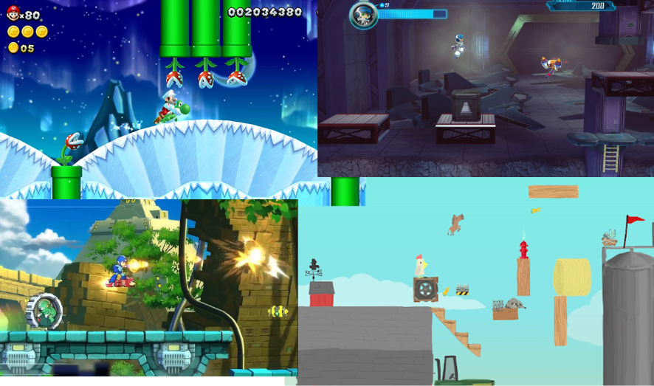

**General Aesthetic**

The theme of *Monk-o-naut* is a 80’s Russian space exploration lab, where the player plates as a chimp trying to escape the research lab. This theme for the game will be prevalent in both the aesthetic, the sound effect and the music. The art style will be more cartoonish, along the lines of Mario and other games in the genre.

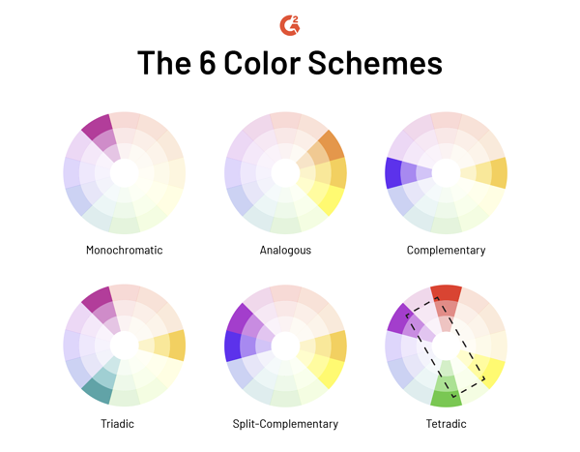

This game will follow a blue and yellow complementary colour scheme, with the background elements adhering closer to the blue side of the scheme. The overall aesthetic will have a level of high saturation in order to try and appeal to the our target

**Core Game Loop**



**Gameplay**

The game play will be split into two distinct sections. The first stage will be the plan and place phase, then this will be followed by the level crossing phase. These two aspects of the game will require the player to think and play differently. If the player falls they will lose a life.

Win condition: Getting to the end of the level in as fast of a time as possible.

Lose condition: Losing all of three player lives lives

Plan and Place phase

During this phase the players will be shown the start and end of the level as well as all of the different obstacles in the level. They’ll also be able to see the various platforms they have to place. Players will also then be directed to place the platforms into the level in any way they want to in order to cross the level in the quickest time.

Platform list:

* Regular straight platform
* Jump pad
* Slope
* Bounce pad

The game will also have a number of obstacles for the player to have to navigate. These obstacles will force the player to have to think tactically about how they place each platform in order to get the best time.

Obstacles

|  |  |  |
| --- | --- | --- |
| **Obstacle** | **How the obstacles work** | **The player will go around the obstacle by..** |
| Boxes | Small cargo boxes that are placed throughout the level | Placing platforms to go around the boxes |
| Rocket parts | Larger obstacles placed throughout the level | Placing platforms to go around the boxes |
| Cargo containers | Large containers that goes across the level, but there is one container open that the player can go through | Placing the platforms to go through the open container and placing them on the other side to continue to the end. |
| Preplaced platforms | These are platforms that are already in the level. | The player can either use the existing platforms or go around them. Whichever they think is best and will get them the quickest time. |

**Level Design**

The main mechanic of the game will be the placing of the levels to allow the player to cross the level as they wish. This means that the levels will be designed to create diverse layouts by placing the start and end positions in the level at different points, and also making sure that obstacles are put into the level in different ways in order to make the player have to think more tactically about their platform layouts.

Once a level has been mocked up and designed we will use playtesting observations and feedback to iterate each level. This will allow us to make the best possible levels for the player.

Mock up

Plan and place phase

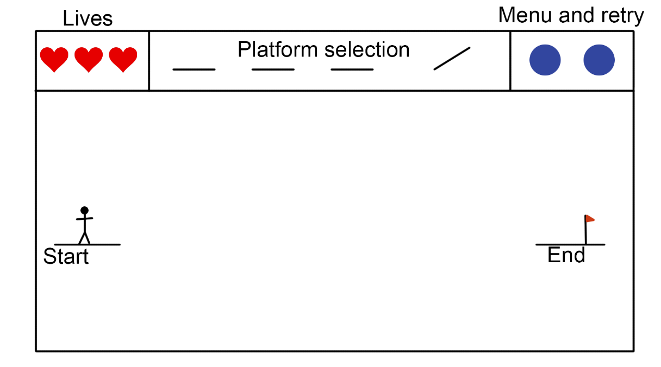

Level crossing phase

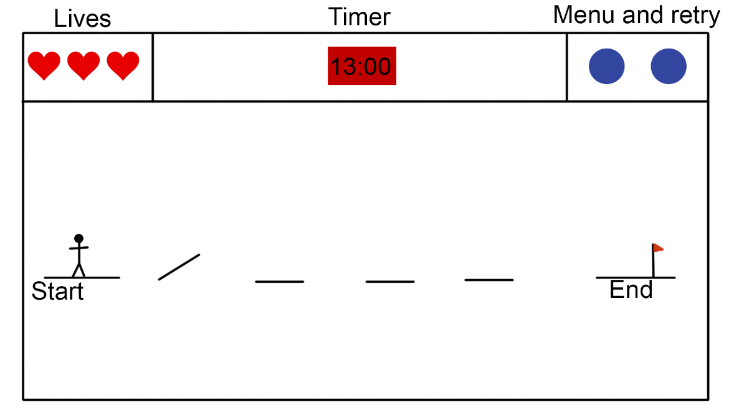

Each level will have times set that will determine how many stars they get at the end of the level. We will decide these times based on playtesters feedback as well as playtesters scores while playing through the levels.

References

* Alscher, D., 2020. *The 6 Color Schemes To Keep Everything Picture Perfect*. [online] Learn.g2.com. Available at: <<https://learn.g2.com/color-schemes>> [Accessed 18 October 2020].
* Amazon.co.uk. 2020. *Watch Clip: New Super Mario Bros. U Gameplay - Best Of Gaming! | Prime Video*. [online] Available at: <<https://www.amazon.co.uk/Clip-Super-Mario-Gameplay-Gaming/dp/B07FY239Y4>> [Accessed 18 October 2020].
* Square, P., 2020. Review: Mighty No. 9 (PS4). [online] Push Square. Available at: <<https://www.pushsquare.com/reviews/ps4/mighty_no_9>> [Accessed 19 October 2020].
* Capcom. 2018 *Mega Man 11 - Gameplay Trailer*. [video] Youtube: IGN. Available at: <<https://www.youtube.com/watch?v=YcXgLcvX7m0>> [Accessed 19 October 2020].
* Flint, S., 2015. Ultimate Chicken Horse: Anger Your Friends. [online] Load the Game. Available at: <<https://bit.ly/3dFM9dI>> [Accessed 19 October 2020].